POC Committee Meeting Agenda

PICES 28th Annual Meeting, October 2019

Dates: October 20th, 6:00 pm - 8:00 pm / October 23rd, 2:00 pm - 6:00 pm
Venue: Victoria, Canada

First half of POC Business Meeting, Sun. October 20, 6-8pm (2 hours)
- Welcome and introductions remarks (5 min)
- Membership updates (5 min) (Appendix I)
- Changes to, adoption of, agenda and appointment of rapporteur (5 min)
- POC Sessions at PICES 2019 (5 min) (Appendix II)
- POC Best Presentation and Poster Awards, Early career judgment for POC (5 min) (Appendix V)
- POC Chair Election (20 min)
- POC Action Plan Part A – Discussion (60 min)
Group Dinner at The Bent Mast, 8-10pm on October 20 (Jim Christian)

Second half of POC Business Meeting (4 hours), Wed. Oct. 23, 2-6pm
- ExGs Progress Reports and future plans of POC active groups (30 min)
  - S-CCME: Joint PICES/ICES Section on Climate Change Effects on Marine Ecosystems (Jan 2012-2017, still continuing)
  - S-CC: Section on Carbon and Climate (Oct 2003 – 2016, still continuing)
  - WG 38: Working Group on Mesoscale and Submesoscale Processes (Nov 2016 - Oct 2019)
  - WG 40: Working Group on Climate and Ecosystem Predictability (Jul 2017 - Oct 2020)
  - AP-CREAMS: Advisory Panel for a CREAMS/PICES Program in East Asian Marginal Seas (Oct 2015 - Oct 2019)
- Requests from and to existing ExGs
- FUTURE Updates (5 min)
- NPESR update - North Pacific Ecosystem Status Report (10 min)
- New Proposals for ExGs, meetings, workshops, symposia, conferences
  - Proposal for new PICES ExGs (e.g. WG, SG, Sections)
  - Ranking of PICES 2019 proposals (Appendix IV)
  - SCOR proposal recommendation and outcomes
- POC Action Plan Part B – Synthesis (30 min)
- POC Report Sheet to SB
- Publications updates (5 min)
  - Scientific Report AP-CREAMS PICES Scientific Report Oceanography of the Yellow and East China Seas (EAST-II region), waiting chapter supplement
  - Scientific Report S-CC on Basin-wide Ocean Acidification and De-oxygenation
  - NPESER
- Upcoming meetings relevant to POC (5 min) (Appendix III)
- Review POC messaging board, documenting business meetings, topic sessions and workshops
- Other business
- Adjourn

Files Upload
Upload any presentation or file to share with the POC committee here:
https://www.dropbox.com/request/7a5C6TD2MI7oPdUukL4n

View POC and Uploaded Files
https://www.dropbox.com/sh/tbtygoalv5l0qsn/AAAXjDQLmdsEyWm6-E3uoTuMa?dl=0

POC Agenda Items & Appendices

POC Business Meeting 5
POC Chair Election 5
POC Action Plan 5
Mission Statement 5
Goal 1: Foster collaboration among scientists within PICES and with other multinational organizations 6
Goal 2: Understand the status and trends, vulnerability and resilience, of marine ecosystems 6
Goal 3: Understand and quantify how marine ecosystems respond to natural forcing and human activities 6
Goal 4: Advance methods and tools 7
Goal 5: Provide relevant scientific information pertinent to North Pacific ecosystems that is timely and broadly accessible 7
Goal 6: Engage with early career scientists to sustain a vibrant and cutting edge PICES scientific community 7
ExGs Progress Reports and Future Plans 7
S-CCME: Joint PICES/ICES Section on Climate Change Effects on Marine Ecosystems (Jan 2012-2017) 7
S-CC: Section on Carbon and Climate (Oct 2003 – 2016, still continuing) 7
WG 38: Working Group on Mesoscale and Submesoscale Processes (Nov 2016 - Oct 2019) 8
WG 40: Working Group on Climate and Ecosystem Predictability (Jul 2017 - Oct 2020) 8
AP-CREAMS: Advisory Panel for a CREAMS/PICES Program in East Asian Marginal Seas (Oct 2015 - Oct 2019) 8
Updates from FUTURE SSC 8
Updates and Q&A NPESR - North Pacific Ecosystem Status Report 8
New Proposals and Funding Requests (ExGs, Meetings, Workshops) 8
Topic Session Proposal PICES 2020: Global warming patterns and multiscale climate variability in the North Pacific, by Jian Ma 8
US CLIVAR Workshop Sponsorship request: Prospects for Multi-year Climate Predictability and Societally-relevant Climate Predictions, by Matt Newman 8
Ranking of PICES 2019 proposals (Sessions, Workshops, Intersessional) 8
Appendix I: POC Membership status 9
Appendix II: POC Sessions at PICES 2019 10
S2: POC Topic Session: Marine heatwaves in the North Pacific: Predictions and impacts in coastal regions 10
S3: POC/MEQ/BIO Topic Session Coastal ocean modelling in the North Pacific 10
S5: POC/BIO/FIS/FUTURE Topic Session Trends in ocean and coastal ecosystems and their services and its future 11
S8: FIS/BIO/POC Topic Session Creating more effective Integrated Ecosystem Assessments (IEAs) in PICES countries 12
S11: FIS/POC/BIO/HD Topic Session Incorporating ecosystem variability and climate change into fisheries management: Progress and challenges for EBFM in the 21st century 13
S12: POC/BIO Topic Session Impacts of meso-/submeso- scale processes on heat/material transport and on marine ecosystems 14
S15: POC/FUTURE Topic Session Advances in North Pacific marine ecosystem prediction 14
W4: POC/BIO/FIS Workshop Circulation, biogeochemistry, ecosystem, and fisheries of the western North Pacific marginal seas: Past and future of CREAMS (Circulation Research of East Asian Marginal Seas) 15
Appendix III: Upcoming Meetings relevant to POC 17
PICES-ICES-NAFO Symposium 17
Symposium on Fisheries Sustainability 17
PICES-2020 Spring School 17
Plastics in the Arctic and Sub-Arctic Region 17
MSEAS-2020 Symposium 17
PICES-2020 Annual Meeting 17
Appendix IV: Proposed Sessions and Workshops PICES 2020 18
Contribution of PICES to the UN Ocean Decade 18
Appendix V: POC Best Presentation and Poster Award 20
Appendix VI: International Observers 22

POC Business Meeting
(Jennifer, if you could please enter your notes in the different sections below)

POC Chair Election
The committee needs to elevet a new POC Chair for the period 2019-2022.

POC Action Plan
The POC committee is asked to complete a new 3-years action plan for the period 2019-2022. The plan is to be developed and mapped onto the PICES goals. The previous action plan is available at the link below but it refers to the previous stratefic plan: https://meetings.pices.int/publications/other/members/Action_Plans/POC_a_plan.pdf

The new strategic plan is summarized below, and available for download here:
https://meetings.pices.int/about/StrategicPlan

The overall vision of PICES is “to engage scientists in trans-disciplinary multi-national collaborations to further our collective understanding of the North Pacific’s natural systems and enhance ecological and social resilience of our coasts and oceans.”

Mission Statement
PICES promotes and coordinates marine research to advance scientific knowledge through the collection and exchange of information and data on the North Pacific Ocean and ecosystems by conducting research on the status and trends of the ocean environment and its interactions with human activities and atmospheric processes. PICES coordinates science to assess the future state of ecosystems as influenced by climate variability and change and human activities.
PICES
- Provides vision and leadership on scientific issues and identifies research
priorities and appropriate approaches for their solution;
- Plans, coordinates, and implements integrated, interdisciplinary research programs and related activities to be undertaken through the national efforts of the member countries;
- Promotes the collection and exchange of data and information related to marine scientific research;
- Assesses ecosystem status and trends and projects future changes;
- Synthesizes scientific information and makes it available to a broad user community and the public;
- Responds to requests from the member countries and other organizations to provide advice on scientific issues;
- Develops capacity within the scientific communities of the member countries; and
- Fosters partnerships with other organizations and programs that share a common interest.

Goal 1: Foster collaboration among scientists within PICES and with other multinational organizations
Collaboration, coordination, and communication lies at the heart of creating scientific knowledge and using it effectively. PICES facilitates multi-national collaborative networks of scientific organizations and programs that have shared goals by carrying out joint activities and exchanges. PICES also provides venues, organizes activities and develops procedures that facilitate the formation of new collaborations and maintenance of existing productive partnerships.

Goal 2: Understand the status and trends, vulnerability and resilience, of marine ecosystems
PICES periodically assesses the status and trends in North Pacific marine ecosystems and improves assessment of the vulnerability and resilience of ecosystems to pressures from climate and human activities. Scientific activities of PICES are dedicated to understanding and quantifying the physical, chemical, and biological processes of North Pacific ecosystems, which underlie these assessment capabilities.

Goal 3: Understand and quantify how marine ecosystems respond to natural forcing and human activities
The North Pacific is dynamic and produces surprising climatic and biological events. PICES is prepared to respond to such events (e.g., El Nino/La Nina, Pacific Decadal Oscillation) and adapt its research strategy to gain insights from regional and global events. Natural processes, such as climate variability and extreme weather, also affect people and where they live, and in turn human activities impact marine ecosystems. PICES improves our understanding of how climate variability and change, catastrophic events, and anthropogenic stressors impact coastal and offshore regions.

Goal 4: Advance methods and tools
Marine ecosystem predictability associated with climate-driven processes is the foundation for providing improved advice for science-driven ecosystem based management. PICES builds on the knowledge of the mechanisms of Pacific climate, regional modeling advances, and ecosystem indicators development to improve climate and ecosystem predictions focusing on seasonal to decadal predictions and to identify and quantify the prediction skill.

Goal 5: Provide relevant scientific information pertinent to North Pacific ecosystems that is timely and broadly accessible
PICES provides periodic products on the current and future state of North Pacific ecosystems, develops reports addressing critical and emerging issues and communicates the results of its scientific activities. PICES science is disseminated broadly, through high quality publications, the PICES web page and other electronic media, and through production of outreach materials. PICES engages user communities from the early stage of product development through to dissemination of the final product to increase their effectiveness.

Goal 6: Engage with early career scientists to sustain a vibrant and cutting edge PICES scientific community
PICES actively encourages the involvement of young scientists in PICES activities and supports opportunities to engage early- and mid-career scientists from other international organizations and non-member countries to foster collaboration. Cooperative programs that are developed by PICES also facilitate capacity building and make it possible for scientists and institutions from all member countries to benefit from the exchange of information and methods and provide education and training opportunities.

ExGs Progress Reports and Future Plans

S-CCME: Joint PICES/ICES Section on Climate Change Effects on Marine Ecosystems (Jan 2012-2017)

S-CC: Section on Carbon and Climate (Oct 2003 – 2016, still continuing)

WG 38: Working Group on Mesoscale and Submesoscale Processes (Nov 2016 - Oct 2019)

WG 40: Working Group on Climate and Ecosystem Predictability (Jul 2017 - Oct 2020)

AP-CREAMS: Advisory Panel for a CREAMS/PICES Program in East Asian Marginal Seas (Oct 2015 - Oct 2019)

Updates from FUTURE SSC

Updates and Q&A NPESR - North Pacific Ecosystem Status Report

New Proposals and Funding Requests (ExGs, Meetings, Workshops)

Topic Session Proposal PICES 2020: Global warming patterns and multiscale climate variability in the North Pacific, by Jian Ma

US CLIVAR Workshop Sponsorship request: Prospects for Multi-year Climate Predictability and Societally-relevant Climate Predictions, by Matt Newman

Ranking of PICES 2019 proposals (Sessions, Workshops, Intersessional)

Appendix I: POC Membership status
Canada: James Christian, Michael Foreman (vice-chair), Jennifer Jackson
China: Fangli Qiao, Fan Wang, Lei Zhou
Japan: Daisuke Hasegawa, Shin-ichi Ito, Hiromichi Ueno
Korea: SungHyun Nam, Chan Joo Jang, Hee-Dong Jeong
Russia: Vyacheslav Lobanov, Elena Ustinova, Yury Zuenko (Vice Chair)
USA: Steven Bograd, Emanuele Di Lorenzo (Chair), Jerome Fiechter

Appendix II: POC Sessions at PICES 2019

S2: POC Topic Session: Marine heatwaves in the North Pacific: Predictions and impacts in coastal regions
Conveners:
Jennifer Jackson (Canada) corresponding, Tetjana Ross (Canada), Toshio Yamagata (Japan), Yun-Wei Dong (China), Emanuele di Lorenzo (USA)
Invited Speakers:
Simone Alin (Pacific Marine Environmental Laboratory, NOAA, USA) Sonia Batten (CPR Survey, Marine Biological Association) Eric C.J. Oliver (Department of Oceanography, Dalhousie University, Halifax, Nova Scotia, Canada)
Description:
Marine heatwaves have been occurring more frequently in recent decades and the biological impacts linked to these abnormally warm ocean temperatures have been making headlines, from sea cucumber die-offs in China to harmful algal blooms along the entire coast of North America. The occurrence of marine heatwaves can largely be explained by anomalous atmospheric conditions, however very little is known about the processes that cause marine heatwaves to persist or dissipate in the ocean. Thus, despite the damage marine heatwaves cause to the health of ocean ecosystems, their arrival, duration, and long-term impact has been difficult to predict without mechanistic knowledge of how they evolve. The focus of this session is to connect researchers studying the physics behind the evolution of marine heatwaves with those studying their impacts on coastal ocean properties and ecosystems, with the goal of improving predictions of future events. This session invites presentations on physical mechanisms that control the formation, spread, and dissipation of marine heatwaves, and on predictions of the future physical, chemical, and biological impacts of marine heatwaves in coastal regions. Presentations relevant to fisheries and aquaculture in the North Pacific are particularly encouraged.

S3: POC/MEQ/BIO Topic Session Coastal ocean modelling in the North Pacific
Co-Sponsor: ICES
Conveners:
Laura Bianucci (Canada) corresponding, Tarang Khangaonkar (USA), Chan Joo Jang (Korea), Susan Allen (Canada), Fei Chai (China), YouYu Lu (Canada)
Invited Speaker:
Mike Foreman - Plenary S3 Speaker (Scientist Emeritus at the Institute of Ocean Sciences, Canada)
Description:
The coastal ocean is a dynamic, complex region where multi-scale processes interact and create conditions suitable for rich ecosystems. For instance, the combination of processes such as land and river runoff, local and remotely- forced upwelling, and wind and tidal mixing can bring nutrients to the surface waters, triggering high primary productivity rates. Coastal waters are subjected to the direct impact of human activities like fishing, aquaculture farming, wastewater runoff, etc. These anthropogenic perturbations along with other pressures exerted by climate change can lead to negative effects in the coastal ocean, such as pollution, hypoxia, ocean acidification, sea level rise, and loss of ecosystem biodiversity. Numerical models of the coastal ocean can be used to understand the physical and biogeochemical drivers in different regions, how these processes can change in the future, and what the implications of these changes are. The complexity of coastal regions, both in terms of geography and physical and biogeochemical dynamics, makes these modelling exercises challenging and region-specific. Nevertheless, commonalities can be drawn among different regions and models, such that the modelling community can benefit immensely by sharing experiences and results. Therefore, this session aims to bring together researchers interested in learning and discussing about the challenges and advances in coastal ocean models. We welcome contributions about any aspect related to these models, from applications in specific regions to regional intercomparisons, including hydrodynamics-only as well as coupled models (physical-biogeochemical, -ice, -sediments, etc.).

S5: POC/BIO/FIS/FUTURE Topic Session Trends in ocean and coastal ecosystems and their services and its future
Convenors:
Shin-ichi Ito (Japan) corresponding, Angelica Peña (Canada), Kirstin Holsman (USA), Xiujuan Shan (China) Igor Yashayaev (Canada)
Invited Speaker:
Naoki H. Kumagai, Plenary S5 Invited Speaker (National Institute for Environmental Sciences, Tsukuba, Japan)
Description:
Oceans and coastal ecosystems provide various ecosystem services to humans. However, ocean and coastal ecosystems are changing and showing trends in regional and synoptic scales responding to global climate change. It is urgent that we elucidate the mechanisms responsible for trends in ocean and coastal ecosystems and enable its future projections. We propose a topic session that involves participation from multiple PICES committees and focuses on trends in ocean and coastal ecosystems responding to global climate change. Specifically, we welcome presentations on topics such as (a) observational approaches to detect trends in ocean and coastal ecosystems, (b) elucidation of mechanisms of the ocean and coastal ecosystem responses, and (c) future projections of ocean and coastal ecosystems.

S8: FIS/BIO/POC Topic Session Creating more effective Integrated Ecosystem Assessments (IEAs) in PICES countries
Co-Sponsor: ICES
Convenors:
Alan Haynie (USA) corresponding, Libby Logerwell (USA), Shigeto Nishino (Japan)
Invited Speaker:
Phillip Levin (University of Washington and The Nature Conservancy)
Description:
Integrated Ecosystem Assessments (IEAs) are an adaptable approach to capture, understand, and communicate the diversity of interactions, ecosystem objectives, and resource trade-offs that occur within an ecosystem. While a core element of IEAs is the characterization of the natural ecosystem, humans are increasingly recognized as being central actors in most ecosystems, rather than an outside agent impacting the ecosystem. In this session, we are interested in elements of IEAs that capture how changes in the natural environment are being measured and the manner in which human activities are being incorporated into IEAs. IEAs have been implemented in a diversity of ecosystems in many PICES and ICES countries. In the United States, for example, IEAs are an important tool through which NOAA describes ecosystem trends and communicates the trade-offs of using marine resources for fisheries versus other uses. ICES, PICES and PAME have also recently worked to develop an IEA of the Central Arctic Ocean (WG 39). In addition, PICES scientists working in PAME have drafted practical guidelines for implementing the Ecosystem Approach across LMEs in the Arctic. Members and chairs of several ICES and PICES working groups are also active in IEA implementation. The goals of this session will be to 1) describe developments in IEAs across PICES countries and beyond, 2) identify opportunities to better integrate social and natural science in IEAs and communicate this with PICES scientists, and 3) discuss future directions for developing and comparing IEAs across PICES countries and LMEs, with the aim of building a foundation for further discussions at the MSEAS-2020 meeting in Yokohama. While the central focus of this session is IEAs, we also welcome presentations that demonstrate successes and challenges in interdisciplinary research. We also encourage submissions that discuss how climate impacts, including vulnerability analyses, can be effectively included in IEAs. We hope that the session will provide a roadmap for how social and natural scientists can more effectively work together in IEAs and in interdisciplinary projects in general. We will conclude the session with a discussion of next steps for IEA research in PICES countries.

S11: FIS/POC/BIO/HD Topic Session Incorporating ecosystem variability and climate change into fisheries management: Progress and challenges for EBFM in the 21st century
Convenors:
Barb Muhling (USA) corresponding, Carrie Holt (Canada), Gerard DiNardo (USA), Kirstin Holsman (USA), Sukyung Kang (Korea)
Invited Speaker:
Stephani Zador (Alaska Fisheries Science Center, NOAA, USA)
Description:
Physical, biological and social components of marine ecosystems interact in complex ways through space and time, resulting in challenges for natural resource managers. Environmental variability and climate change can drive shifts in the spatial distribution and productivity of target and bycatch species. This can impact the effectiveness of stock assessment and management. Ecosystem-Based Fisheries Management (EBFM) aims to address these issues by including environmental effects, species interactions, and other ecosystem-level processes in the management process for exploited species, in addition to fishing pressure. Ecosystem variables can be considered qualitatively in management advice by providing context about the state of the ecosystem or quantitatively in models that derive management-relevant quantities (e.g., allowable catch). However, despite the theoretical benefits of EBFM, most stock assessments and management measures still use single-species models with no ecosystem information incorporated. In this session, we seek examples describing how ecosystem variability and climate change have been considered in management advice qualitatively and/or quantitatively, or proposals on how management advice could consider those variables. Management applications could include the development or modification of stock assessment models, dynamic ocean management rules, bycatch mitigation, multi-species assessments, or other decision processes. This session will also address: how can qualitative information on ecosystem state be integrated with quantitative outputs from stock assessments? How can this information and the underlying uncertainties be effectively communicated to managers? In addition we seek examples of how decisions that consider ecosystem and climate variability and change have been or could be evaluated a priori (e.g., through management strategy evaluation) or retrospectively. Does management advice that accounts for theses variables result in better decisions? The session will begin with scientific presentations, followed by a discussion panel of scientists and natural resource managers, which will explore practical aspects of operationalizing EBFM, and promote exchange of ideas between the scientific and management communities.

S12: POC/BIO Topic Session Impacts of meso-/submeso- scale processes on heat/material transport and on marine ecosystems
Convenors:
Hiromichi Ueno (Japan) corresponding, Tetjana Ross (Canada), Olga O. Trusenkova (Russia)
Invited Speaker:
Jody Klymak (School of Earth and Ocean Sciences, University of Victoria, BC, Canada)
Description:
Mesoscale and submesoscale processes (with scales of 0.1 – 100 km) are widely distributed in the world’s oceans; from coastal regions to the open ocean. These phenomena can be examined using in-situ and satellite observations as well as high-resolution numerical models. However, there is still a lot to be learned about the detailed structure and dynamics of these fine-scale features. Studies indicate that mesoscale and submesoscale processes have a significant impact on horizontal heat and material transport, e.g. from coastal regions to the open ocean, as well as vertical transport, e.g. from subsurface to surface layers. The heat and material transport by mesoscale and submesoscale processes are important not only in the context of physics and chemistry, but also to marine ecosystems including plankton, nekton, birds and mammal. This topic session aims to discuss how the physics, chemistry, biology and fisheries of mesoscale and submesoscale processes interact and also how these processes mediate interaction between regions (lateral) and layers (vertical). We invite presentations based on both observations and modeling.

S15: POC/FUTURE Topic Session Advances in North Pacific marine ecosystem prediction
Convenors:
Mike Jacox (USA), corresponding, Fei Chai (China), Jinqiu Du (China), Shoshiro Minobe (Japan)
Invited Speakers:
Takeshi Doi (JAMSTEC, Japan) Nicole Lovenduski - Plenary S15 Speaker (University of Colorado, USA) Stephanie Brodie (UC Santa Cruz, USA)
Description:
Modern ocean and ecosystem models are rapidly developing the ability to make skillful forecasts of the physical, and more recently biogeochemical and higher trophic level, components of marine ecosystems at timescales from days to decades. Such forecasts often align with the tactical decision-making timescales of individuals, businesses, and governments, giving them significant potential to inform climate-ready management strategies. Much work has now been done to identify potentially predictable ecosystem components and to develop prototype forecast systems. This session will be a forum to learn and discuss how robust climate-ecosystem relationships are being (or can be) exploited for North Pacific marine ecosystem forecasts. We seek contributions that highlight recent advances in prediction of all earth system components that aid marine ecosystem forecasts, from physics to biogeochemistry, higher trophic levels, and potentially socioeconomic impacts (e.g., fish catch).
Presenters are encouraged to submit manuscripts from this session to a special issue proposed in a leading scientific journal.

W4: POC/BIO/FIS Workshop Circulation, biogeochemistry, ecosystem, and fisheries of the western North Pacific marginal seas: Past and future of CREAMS (Circulation Research of East Asian Marginal Seas)
Convenors:
SungHyun Nam (Korea) corresponding, Fei Yu (China), Joji Ishizaka (Japan), Yuri I. Zuenko (Russia)
Invited Speaker:
Kuh Kim (Formerly, Professor of Physical Oceanography at Seoul National University, Korea)
Description:
The western North Pacific, one of the areas of the global ocean most affected by climate change and anthropogenic activities, consists of several marginal seas. Two time series programs have contributed to significant advances in understanding of these seas/regions, named East Asian Seas Time-series (EAST-I and EAST-II regions) since the CREAMS (Circulation Research of East Asian Marginal Seas) program was initiated beyond the national borders several decades ago (early 1990s). This workshop will provide a forum for summarizing progress made during the decades of CREAMS and during the 15 years of the PICES Advisory Panel (AP-CREAMS; active since 2005), and for envisioning the future of CREAMS over the coming decades. This workshop is an opportunity to share the knowledge/findings and experience/lessons learned in hydrodynamics, biogeochemistry, ecosystem, and fisheries variability at multiple scales in the regions. We seek contributions from studies including, but not limited to, weakening of ventilation and decrease of dissolved oxygen in deep waters, eutrophication and development of hypoxia and acidification, changes of biological community structures, mixing and use of tracers as new methods, observational capabilities, and more. We will also discuss remaining issues, capacity building, new challenges, and future CREAMS plans during this workshop.

Appendix III: Upcoming Meetings relevant to POC

PICES-ICES-NAFO Symposium
Nov. 5-7, 2019
Tromsø, Norway

Symposium on Fisheries Sustainability
November 18–21, 2019
Rome, Italy

PICES-2020 Spring School
Coastal Ocean Observatory Science
March 4-8, 2020
Kagoshima, Japan

Plastics in the Arctic and Sub-Arctic Region
April 21-23, 2020
Reykjavik, Iceland

MSEAS-2020 Symposium
May 25-29, 2020
Yokohama, Japan

PICES-2020 Annual Meeting
Oct 22 – Nov 1, 2020
Qingdao, China

Appendix IV: Proposed Sessions and Workshops PICES 2020
Submissions are open for PICES 2020 proposals. At this time there is only one proposal submitted. You can view the list here, after you login into the PICES protal: https://www.pices.int/secure/proposals/view/sessions/?ID=57

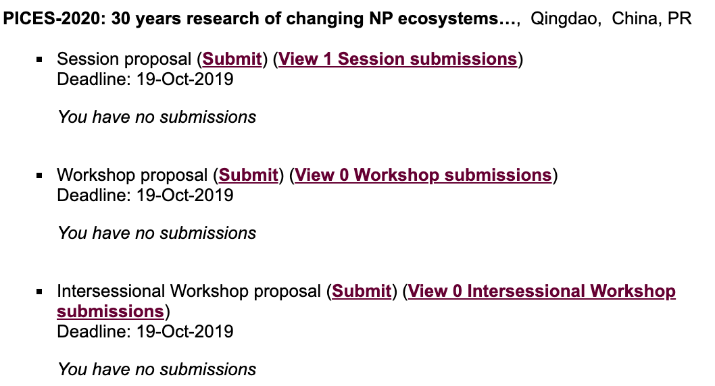

Contribution of PICES to the UN Ocean Decade
“How does 30 years of research on changing North Pacific ecosystems inform the UN Decade of Ocean Science for Sustainable Development Goals (SDGs)?”
PICES-2020 Annual Meeting
Oct 22 – Nov 1, 2020
Qingdao, China
https://meetings.pices.int/meetings/annual/2020/pices/scope

For 29 years, PICES has conducted investigations of North Pacific ecosystems. There has been a significant focus on multidecadal ecological processes and a more recent emphasis on the impacts of changes in the ocean on the human societies that rely on the North Pacific. The FUTURE Science Plan has identified several important science questions about the status and future of North Pacific marine ecosystems. As a result, PICES scientists are well-positioned to contribute to the United Nations Decade of Ocean Science for Sustainable Development. It is now urgent for PICES scientists to identify the most important science questions which must be answered to achieve the objectives of the Sustainable Development Goals and to suggest effective ways to answer these questions, mobilizing the coordination within PICES and collaborations with other partners.

We welcome submissions for topic sessions and workshops that address these issues, including : 1) What are the greatest issues of concern regarding the status and health of the North Pacific Ocean, 2) Are there critical science issues for ocean Sustainable Development Goals that PICES is not addressing? and 3) What kind of blueprint is necessary to facilitate the coordinated ocean observation, prediction and ecosystem and social service systems for the North Pacific, so that the diverse interests of PICES significantly contribute to the goals and objectives of the UN Ocean Decade.

Appendix V: POC Best Presentation and Poster Award
These are last year criteria, there will be an update at the SB meeting prior to the POC business meeting.
Eligibility
- Oral – 1st author & presenter should be early career scientist.
- Poster – previously no age limit but for this meeting limited to only ECS

Sessions
- POC judging will be for POC Poster, S2, S3, S12, POC, W4 ECS orals and posters, and any ECS posters arising from W4. (Tentatively POC will be responsible for judging total of 11 ECS orals and 5 ECS posters)]
- Evaluation sheet (sample below) have been sent by email and are available in the POC shared folder. [Rosalie will also provide hard copies in SB mail folder in Secretariat room at meeting/ and can also send electronically if requested.]
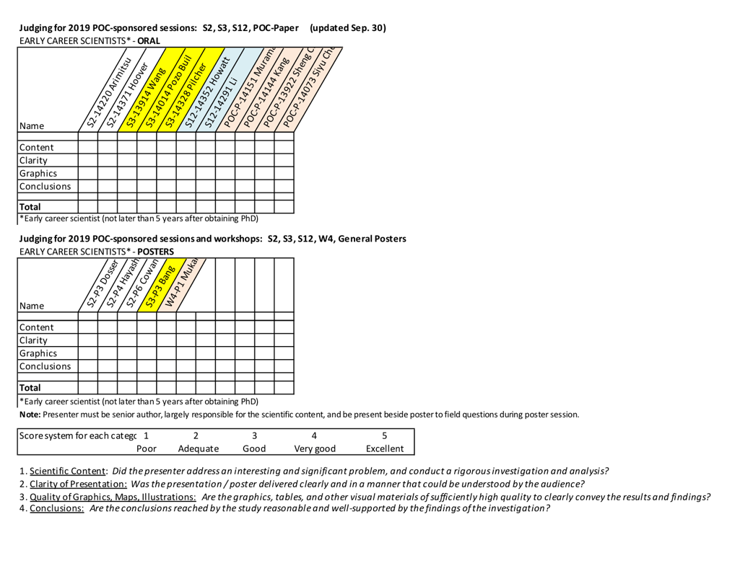

Appendix VI: International Observers
Organization | Representative | Meeting
Argo | Tetjana Ross tetjana.ross@dfo-mpo.gc.ca | POC, MONITOR
CLIVAR | Annalisa Bracco abracco@gatech.edu | POC
ESSAS | Franz Mueter fmueter@alaska.edu | BIO, FIS, HD, POC, MONITOR
IASC | Sei-Ichi Saitoh ssaitoh@salmon.fish.hokudai.ac.jp | MONITOR
ICES | Bill Karp/Anne Christine Brusendorffbkarp@uw.edu anne.christine@ices.dk | SB (Sun, Oct. 20)
IPHC | David Wilson/Josep Planas david@iphc.intjosep@iphc.int | FIS, WG 35
IODE | Yutaka Michida (ex officio) ymichida@aori.u-tokyo.ac.jp | TCODE
IWC | Tsutomu Tamura tamura@cetacean.jp | S-MBM, BIO
NANOOS | Jack Barth jack.barth@oregonstate.edu | MONITOR
NEAR-GOOS | Slava Lobanov lobanov@poi.dvo.ru | MONITOR
NOWPAP | Takafumi Yoshida (ex officio) yoshida@npec.or.jp | S-HAB, MEQ
NPAFC | V. Radchenko vlrad@npafc.org ; Mark Saunders msaunders@yearofthesalmon.org | FIS, WG 35
NPFC | A. Zavolokin azavolokin@npfc.int | SB (Sun, Oct. 20), FIS
NPFMC | Gordon Kruse Gordon.Kruse@alaska.edu | FIS
NPRB | Mathew Baker Matthew.Baker@nprb.org  Betsy Baker betsy.baker@nprb.org | SB (Sun, Oct. 20), MONITOR, WG 35
CPR Survey of the Marine Biological Association | Willie Wilson wilwil@mba.ac.uk, Sonia Batten Sonia.Batten@mba.ac.uk | SB (Sun, Oct. 20), MONITOR
SOLAS | Lisa Miller Lisa.Miller@dfo-mpo.gc.ca | S-CC, BIO, POC

