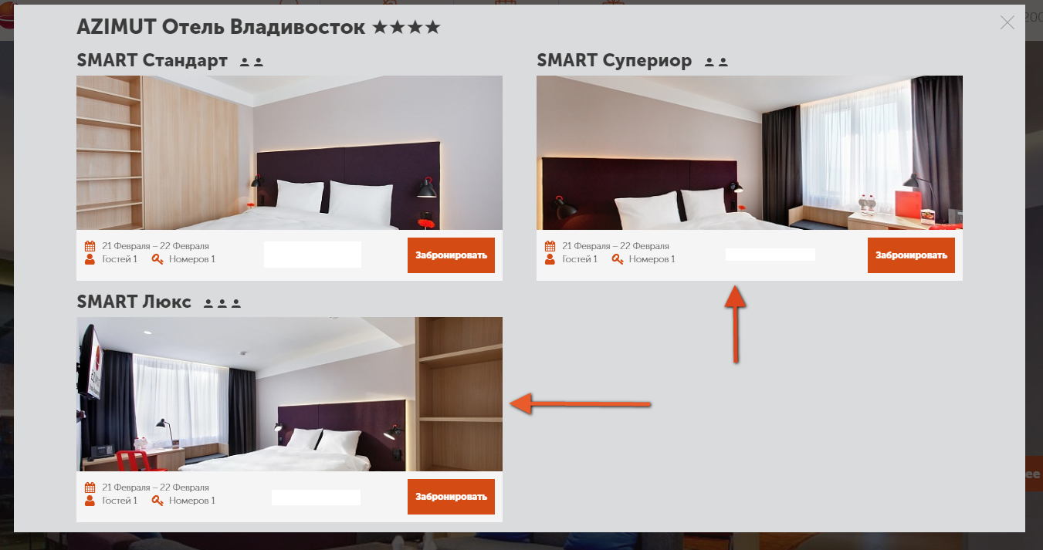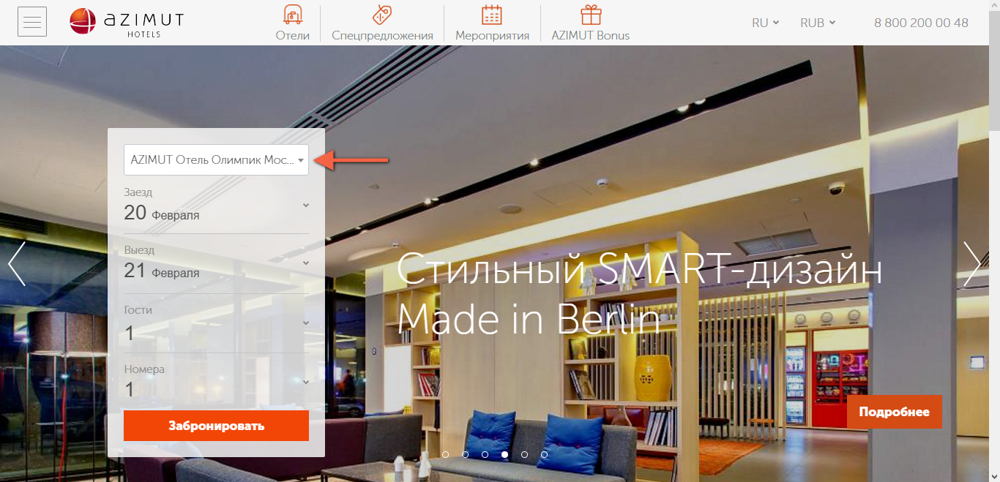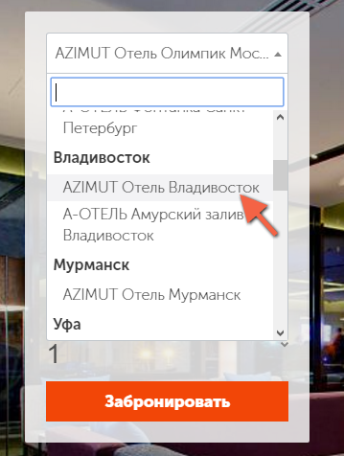 **How to book rooms in AZIMUT Hotel Vladivostok through azimuthotels.com using a special group code**

**(for our guests from overseas)**

5. Choose room type and click "Book"

2. Choose AZIMUT Hotel Vladivostok

3. Choose arrival/departure dates, number of adults/children and number of rooms

4. Click "Book"

1. Type azimuthotels.com in address bar. Choose language in the upper right hand corner

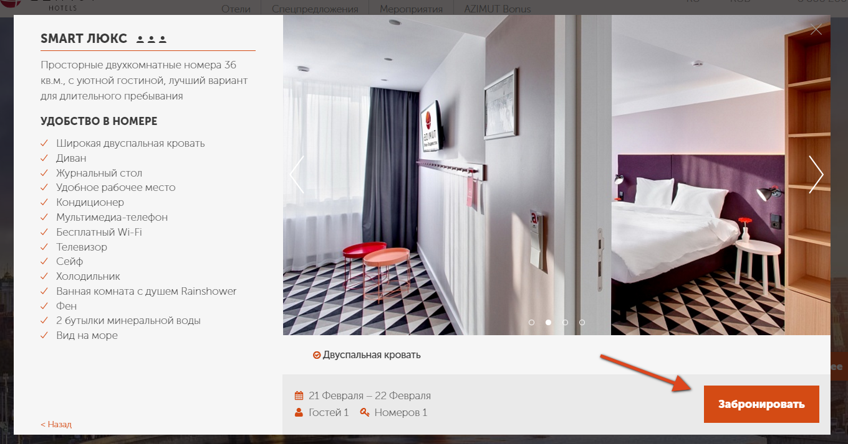

6. Check your reservation details and click “Book”

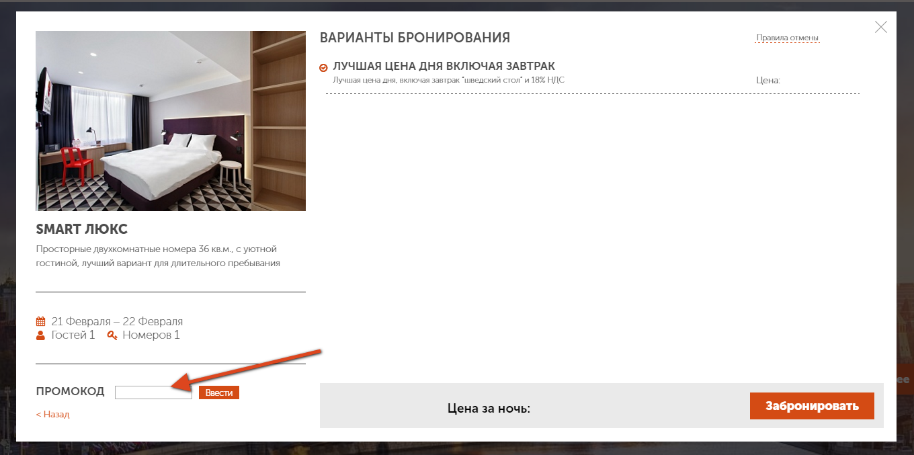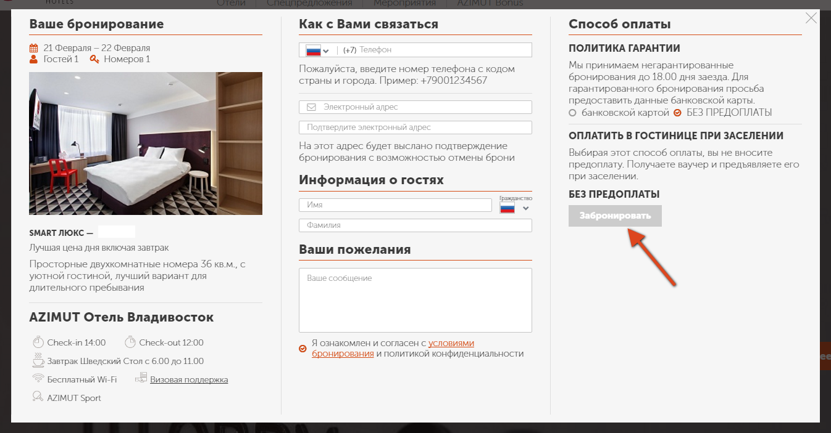

**7. Type group code TINRO**

8. Fill in the required fields

9. Click “book”